Knights Serve and Honor Veterans

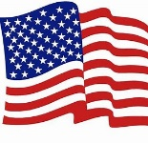

Virginia council hosts dinner for Honor Flight veterans visiting D.C.
ARLINGTON, Va. — Hollywood tries to get historic events right, but there’s nothing like talking to someone who experienced it firsthand, said Grand Knight John Rovinski Jr. of Edward Douglass White Council 2473 in Arlington, Va. Rovinski was one of dozens of volunteers ⁠— entire families, scouting troops, parish members and Knights ⁠— on hand to honor nearly 300 veterans at the council’s Honor Flight Dinner.
“There’s nothing like that first person account of a historical event. You read about things like Pearl Harbor or the Battle of the Bulge in history books. These people were part of these events, and they can tell you firsthand about their experience,” Rovinski said. “It’s really something to listen and talk to them.”
The council has served more than 16,000 participants of the Honor Flight Veterans Network since 2012. The Honor Flight Veterans Network is a non-profit organization dedicated to honoring United States military veterans by bringing them to visit the war memorials in Washington, D.C., at no cost to the veterans.
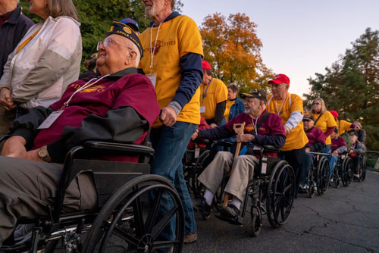

The Knights host the veterans visiting D.C., welcoming them to their council meeting place and serving them a meal.
“We reach out and see how we can serve them,” Rovinski said. “Sometimes the meal is donated, sometimes we pay for it, sometimes a business donates it. Volunteers come in to help, we get color guards from the military, and volunteers from everywhere from scout troops to biker groups. Anyone is welcome to help pay tribute to these brave men and woman who gave us so much.”
Two groups came in for the latest Honor Flight Dinner, and the council adjusted to accommodate both groups in two shifts.
Hundreds of volunteers were on hand at the council meeting place when the veterans arrived to cheer these men and women who served in the Armed Forces and to welcome them. After being greeted, the veterans were treated to dinner. Dinner included a speaking program with James Byrne, former deputy secretary for the Department of Veterans Affairs.
In his address, Byrne spoke of the Department of Veterans Affairs commitment, as well as his personal commitment, to ensuring that veterans get the support they need.
Also addressing the attendees was Robert Szerszynski, the Knights of Columbus state deputy for Virginia. He thanked the Honor Flight Network and members of Council 2473.
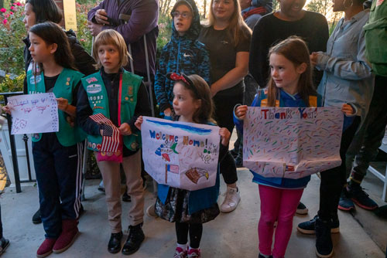
“To date, over 20,000 veterans have been where you are now. I thank the members of this council for their dedication and support to this worthwhile event,” State Deputy Szerszynski said.
Stepping up to honor and serve veterans is part of what the Knights do and is natural for the council, Rovinski said. “We do whatever it takes to make these veterans comfortable. To make them feel welcome and valued. It’s what we do as Knights.”
Since its beginnings the Knights of Columbus have honored and served veterans around the world. This includes annually working with the Archdiocese for the Military Services in sending thousands of military personnel to a Marian apparition site in France through the Warriors to Lourdes Pilgrimage.
Let us also remember, and honor, the Sir Knights of Assembly 3135, and our brothers in Council 11959, who served in the military and continue to serve the Church and our blessed Order.

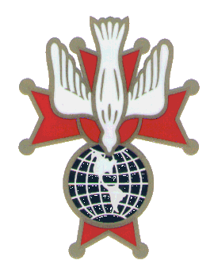GOTO 11-12-23

